## Introduction

The photosystems of plant cells are central to our understanding of plant metabolism. A vital component is the hill reaction which has been discovered by Hill in 1937. In this step, the electrons from water are transferred to an electron acceptor releasing oxygen in the process. For this purpose, we reduced the blue dye 2,6-dichlorophenolindophenol (DCPIP) into its colourless form. To illustrate interruption of the electron chain we used the blocking agents Dichlorphenyldimethylurea (DCMU) and Atrazin.

## Hypothesis

No reduction of DCPIP should occur if the block agents are present.

## Methods

|  |  |
| --- | --- |
| **Medium A** | **Medium B** |
| 0.33 M sorbitol  30 mM KCl  5 mM NaCl  25 mM Hepes-KOH pH 7.6  2 mM EDTA  1 mM MgCl2  1 mM MnCl2  0.5 mM KH2PO4  5 mM ascorbate  4 mM cysteine | 30 mM KCl  5 mM NaCl  25 mM Hepes-KOH pH 7.6  2 mM EDTA  1 mM MgCl2  1 mM MnCl2 |

*Table 1.* Medium B was used to extract

Fresh pea leaves were added to Medium A in the mixer and blended subsequently. Leaves were filtrated through a layer of cloth (wettened with Medium A). The chloroplast suspension was distributed in 50 ml centrifuge tubes. After spinning each tube for 5 minutes in a precooled centrifuge at 2000 g (4000 rpm; SS34 Rotor) the supernatant was discarded. The chloroplasts were resuspended in 20 ml Medium B and left on ice for 4 minutes. After spinning the suspension for 5 minutes at 3000 rpm the supernatant was discarded. The thylakoids were resuspended in 5 ml Medium B and left in the dark for 5 mins. We prepared an extinction series for DCMU (in 10% ethanol) making solutions with the following concentrations: 5 x 10-5, 5 x 10-6, 5 x 10-7 and 5 x 10-8 M. Analogously, we prepared an extinction series for atrazine (in 100% ethanol) in the same fashion.

## Results

|  |
| --- |
| Extinction [M-1 cm-1] |
| 0.876 |
| 0.717 |
| 0.871 |
| 0.736 |
| 0.933 |
| 1.004 |
| 0.824 |
| 0.747 |
| 0.914 |
| 0.803 |
| 0.697 |
| 0.699 |

*Table 2.* Measured extinction coefficients.

The difference of tube 1 (no thylakoids) and tube 2 (light reaction) was set as 100 % of DCPIP reduction. The other values were expressed as % of maximal DCPIP reduction.

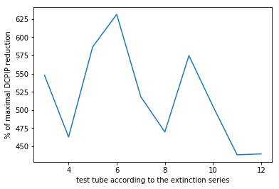  
*Table 3*.

## Discussion

In our experiment, no DCPIP was reduced. According to the graph in table 3, the potency of DCMU seems to be slightly higher than atrazine.